Al-ayen Iraqi university

College of Heaith &Medical Technology

Department of Anasthesia



**Coronary circulation**

**By: Khitam AL-mohammed**

* **Coronary Circulation**

The heart is a remarkable pump composed largely of cardiac muscle cells that are incredibly active throughout life. Like all other cells, **a cardiomyocyte** requires a reliable **supply of oxygen and nutrients**, and a way to remove wastes, so it needs a dedicated, complex, and extensive coronary circulation. And because of the critical and **nearly ceaseless activity** of the heart throughout life, this need for a blood **supply is even greater** than for a typical cell. However, **coronary circulation is not continuous**; rather, it **cycles**, reaching a **peak when** the heart muscle is **relaxed** and nearly **ceasing while it is contracting**.

* **Coronary Arteries**

**Coronary arteries** supply blood to the **myocardium** and other components of the heart. The **first portion** of the aorta after it arises from the **left ventricle** gives rise to the coronary arteries. There are **three dilations in the wall of the aorta** just **superior to** the aortic **semilunar valve**. Two of these, the **left posterior aortic sinus** and **anterior aortic sinus**, give rise to the **left and right** **coronary arteries**, respectively. The **third** sinus, the **right posterior aortic sinus**, typically does **not give** rise to a **vessel**. Coronary vessel branches **that remain on the surface** of the heart and follow the **sulci** are called **epicardial coronary** arteries. The **left coronary artery** distributes blood **to the left side** of the heart, the left **atrium and ventricle**, and the **interventricular septum**. 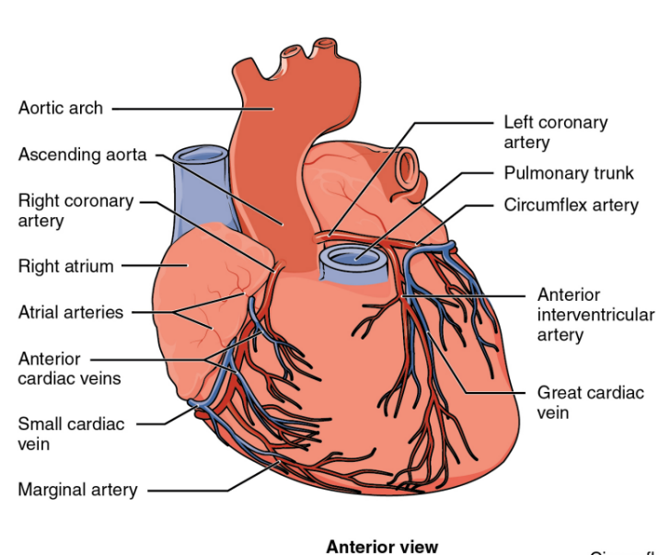

It runs **posterior to the pulmonary trunk** and almost immediately branches **into two vessels**: the **circumflex** and **anterior interventricular arteries**. The **circumflex** artery follows the **coronary sulcus to the left** and eventually **fuses** with the **small** branches of the **right coronary** artery. The **larger anterior interventricular artery**, also known as the left anterior descending artery (**LAD**), follows the **anterior interventricular sulcus** around the pulmonary trunk. Along the way it gives rise to numerous **smaller branches** that interconnect **with** the **branches** of the **posterior interventricular artery**, forming anastomoses. **An anastomosis** is an area where vessels unite to form interconnections that normally allow blood to circulate to a region even if there may be partial blockage in another branch. The anastomoses in the heart are **very small**. Therefore, this ability is somewhat **restricted in the heart** so a coronary artery blockage often results in death of the cells (myocardial infarction) supplied by the particular vessel.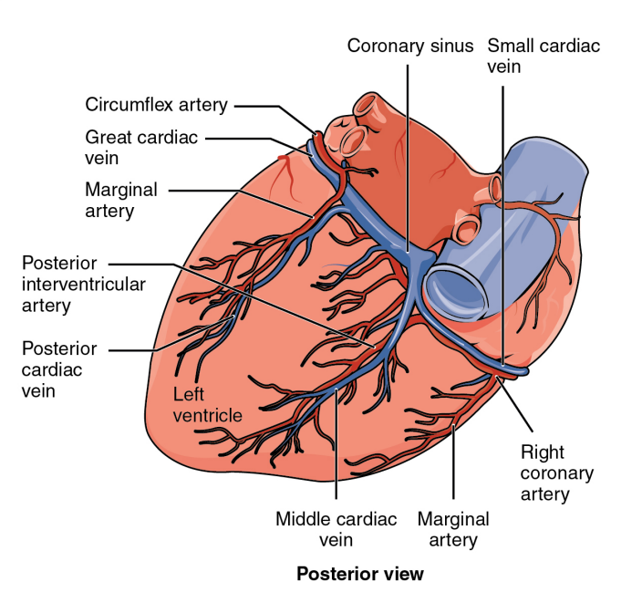

The **right coronary artery** proceeds along the **coronary sulcus** and distributes blood **to** the **right atrium**, **portions of both ventricles**, and the cardiac **conducting system**. Normally, **one or more marginal arteries arise** from the right coronary artery **inferior** to the right atrium. The **marginal** arteries supply blood **to** the **superficial portions** of the **right ventricle**. On the **posterior** surface of the heart, the right coronary artery abruptly **dips inferiorly** and becomes the **posterior interventricular artery**, also known as the **posterior descending artery**. It runs along the posterior portion of the interventricular sulcus toward the **apex** of the heart, giving rise to branches that supply the posterior aspects of the interventricular **septum** and portions of **both ventricles**. Figure presents the major vessels of coronary circulation from both the anterior and posterior views.

* **Coronary Artery Disease**

Coronary artery disease is the **leading cause of death** worldwide. It occurs when the **buildup** of plaque—a fatty material including **cholesterol,** connective **tissue**, **white blood cells**, and some smooth **muscle cells**—within the walls of the arteries **obstructs the flow of blood** and decreases the flexibility or **compliance of the vessels**. This condition is called **atherosclerosis**, a hardening of the arteries that involves the accumulation of plaque. As the coronary blood vessels become occluded, the flow of blood to the tissues will be restricted, a condition called **ischemia** that causes the cells to receive **insufficient amounts of oxygen**, called **hypoxia.** Figure shows the blockage of coronary arteries highlighted by the injection of dye. Some individuals with coronary artery disease report **pain radiating from the chest called angina pectoris**, but others remain **asymptomatic**. If untreated, coronary artery disease can lead to MI (Myocardial infarction) or a heart attack.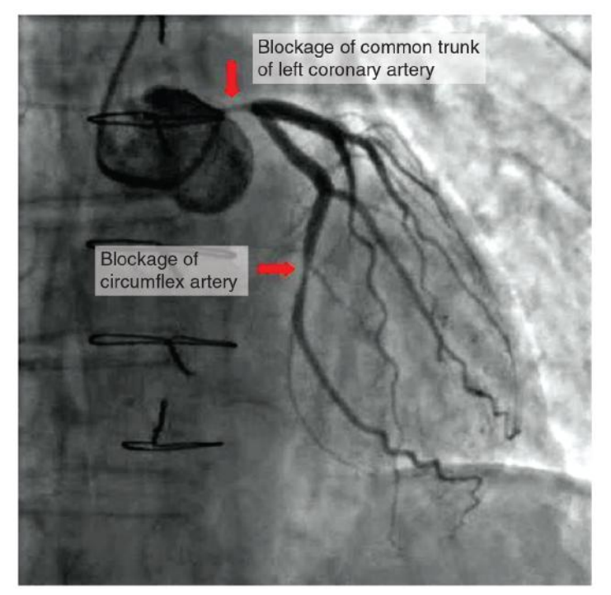

The disease progresses slowly and often begins in children and can be seen as fatty “streaks” in the vessels. It then gradually progresses throughout life. Well-documented **risk factors include smoking, family history, hypertension, obesity, diabetes, high alcohol consumption, lack of exercise, stress, and hyperlipidemia** or high circulating levels of lipids in the blood.

**Treatment**s may include **medication, changes to diet** and **exercise, angioplasty** with a balloon catheter, insertion of a **stent**, or coronary **bypass** procedure. Angioplasty is a procedure in which the occlusion is mechanically widened with a balloon. A specialized catheter with an expandable **tip is inserted into** a superficial vessel, normally in the **leg,** and then directed to the site of the occlusion. At this point, the balloon is inflated to compress the plaque material and to open the vessel to increase blood flow. Then, the balloon is deflated and retracted. A stent consisting of a specialized mesh is typically inserted at the site of occlusion to reinforce the weakened and damaged walls. Stent insertions have been routine in cardiology for more than 40 years. 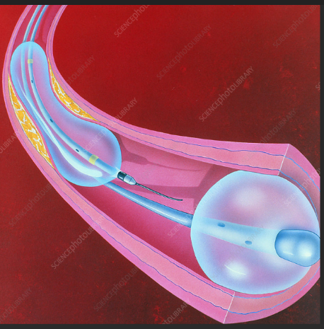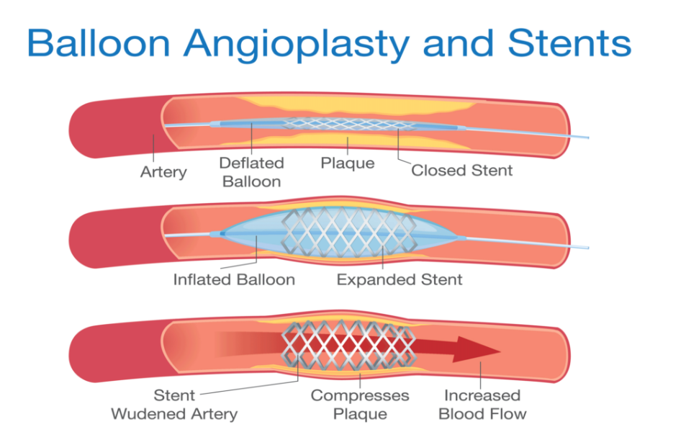

**Coronary bypass** surgery may also be performed. This surgical procedure grafts a replacement vessel obtained from another, less vital portion of the body to bypass the occluded area. This procedure is clearly effective in treating patients experiencing a MI, but overall **does not increase longevity**. Nor does it seem advisable in patients with stable although diminished cardiac capacity since frequently loss of mental acuity occurs following the procedure. Long-term changes to behavior, emphasizing diet and exercise plus a medicine regime tailored to lower blood pressure, lower cholesterol and lipids, and reduce clotting are equally as effective.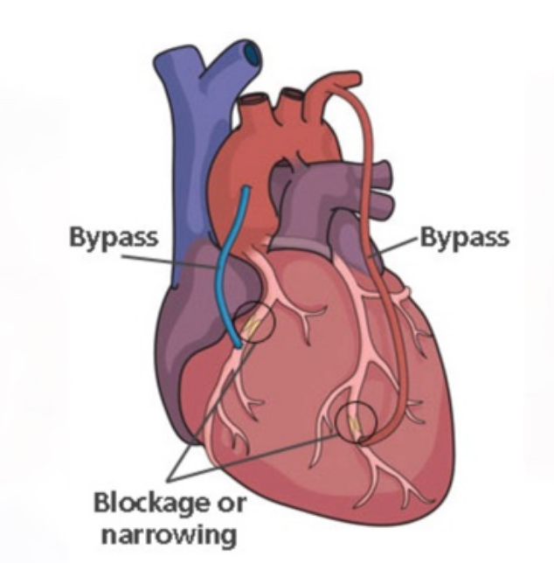

* **Heart: Myocardial Infarction**

Myocardial infarction (MI) is the formal term for what is commonly referred to as a heart attack. It normally results from a lack of blood flow (ischemia) and oxygen (hypoxia) to a region of the heart, resulting in death of the cardiac muscle cells. An MI often occurs when a coronary artery is blocked by the buildup of atherosclerotic plaque consisting of lipids, cholesterol and fatty acids, and white blood cells, primarily macrophages. It can also occur when a portion of an unstable atherosclerotic plaque travels through the coronary arterial system and lodges in one of the smaller vessels. The resulting blockage restricts the flow of blood and oxygen to the myocardium and causes death of the tissue. MIs may be triggered by excessive exercise, in which the partially occluded artery is no longer able to pump sufficient quantities of blood, or severe stress, which may induce spasm of the smooth muscle in the walls of the vessel. In the case of acute MI, there is **often sudden pain beneath the sternum** (retrosternal pain) called angina pectoris, often radiating down the **left arm in males** **but not in female patients.** Until this anomaly between the sexes was discovered, many female patients suffering MIs were misdiagnosed and sent home. In addition, patients typically present with difficulty breathing and shortness of breath (dyspnea), irregular heartbeat (palpitations), nausea and vomiting, sweating (diaphoresis), anxiety, and fainting (syncope), although not all of these symptoms may be present. Many of the symptoms are shared with other medical conditions, including anxiety attacks and simple indigestion, so differential diagnosis is critical. It is estimated that between 22 and 64 percent of MIs present without any symptoms.

**An MI** can be confirmed by examining the patient’s **ECG**, which frequently reveals **alterations in the ST and Q** components. Some classification schemes of MI are referred to as **ST-elevated** MI (STEMI) and **non-elevated MI** (nonSTEMI). In addition, echocardiography or cardiac magnetic resonance imaging may be employed. Common blood tests indicating an MI include **elevated levels of creatine kinase** MB (an enzyme that catalyzes the conversion of creatine to phosphocreatine, consuming ATP) and cardiac **troponin** (the regulatory protein for muscle contraction), both of which are released by damaged cardiac muscle cells. 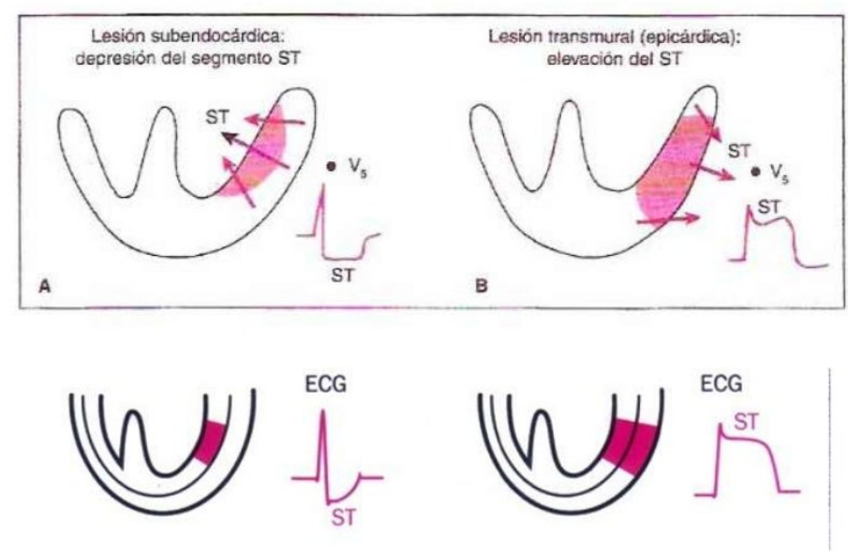

Immediate treatments for MI are essential and include administering supplemental oxygen, aspirin that helps to break up clots, and nitroglycerine administered sublingually (under the tongue) to facilitate its absorption. Despite its unquestioned success in treatments and use since the 1880s, the mechanism of nitroglycerine is still incompletely understood but is believed to involve the release of nitric oxide, a known vasodilator, and endothelium-derived releasing factor, which also relaxes the smooth muscle in the tunica media of coronary vessels. Longer-term treatments include injections **of thrombolytic agents such as streptokinase** that dissolve the clot, the anticoagulant heparin, balloon angioplasty and stents to open blocked vessels, and bypass surgery to allow blood to pass around the site of blockage. If the damage is extensive, coronary replacement with a donor heart or coronary assist device, a sophisticated mechanical device that supplements the pumping activity of the heart, may be employed. Despite the attention, development of artificial hearts to augment the severely limited supply of heart donors has proven less than satisfactory but will likely improve in the future. MIs may trigger cardiac arrest, but the two are not synonymous. Important risk factors for MI include cardiovascular disease, age, smoking, high blood levels of the low-density lipoprotein (LDL, often referred to as “bad” cholesterol), low levels of high-density lipoprotein (HDL, or “good” cholesterol), hypertension, diabetes mellitus, obesity, lack of physical exercise, chronic kidney disease, excessive alcohol consumption, and use of illegal drugs.

* **Coronary Veins**

Coronary veins drain the heart and generally parallel the large surface arteries. The **great cardiac** vein can be seen initially on the surface of the heart following the **interventricular sulcus**, but it eventually flows along the coronary sulcus into the **coronary sinus** on the posterior surface. The great cardiac vein initially parallels the anterior interventricular artery and drains the areas supplied by this vessel. It receives several major branches, including the **posterior cardiac vein**, the **middle cardiac vein, and the small cardiac vein**. The posterior cardiac vein parallels and drains the areas supplied by the marginal artery branch of the circumflex artery. The middle cardiac vein parallels and drains the areas supplied by the posterior interventricular artery. **The small cardiac** vein parallels the right coronary artery and drains the blood from the posterior surfaces of the right atrium and ventricle. The coronary sinus is a large, thin-walled vein on the posterior surface of the heart lying within the atrioventricular sulcus and emptying directly into the right atrium. **The anterior cardiac veins** parallel the small cardiac arteries and **drain the anterior surface of the right ventricle**. Unlike these other cardiac veins, it bypasses the coronary sinus and drains directly into the right atrium. 